Md. Nazrul Islam
Department of Chemistry
J.L. N College, Chakradharpur
Mutations and Genetic Diseases

The sequence of nucleotides in a cell’s deoxyribonucleic acid (DNA) is what ultimately determines the sequence of amino acids in proteins made by the cell and thus is critical for the proper functioning of the cell. On rare occasions, however, the nucleotide sequence in DNA may be modified either spontaneously (by errors during replication, occurring approximately once for every 10 billion nucleotides) or from exposure to heat, radiation, or certain chemicals. Any chemical or physical change that alters the nucleotide sequence in DNA is called a mutation. When a mutation occurs in an egg or sperm cell that then produces a living organism, it will be inherited by all the offspring of that organism.
Common types of mutations include substitution (a different nucleotide is substituted), insertion (the addition of a new nucleotide), and deletion (the loss of a nucleotide). These changes within DNA are called point mutations because only one nucleotide is substituted, added, or deleted (Figure :"Three Types of Point Mutations"). Because an insertion or deletion results in a frame-shift that changes the reading of subsequent codons and, therefore, alters the entire amino acid sequence that follows the mutation, insertions and deletions are usually more harmful than a substitution in which only a single amino acid is altered.

Fig: Three Types of Point Mutations
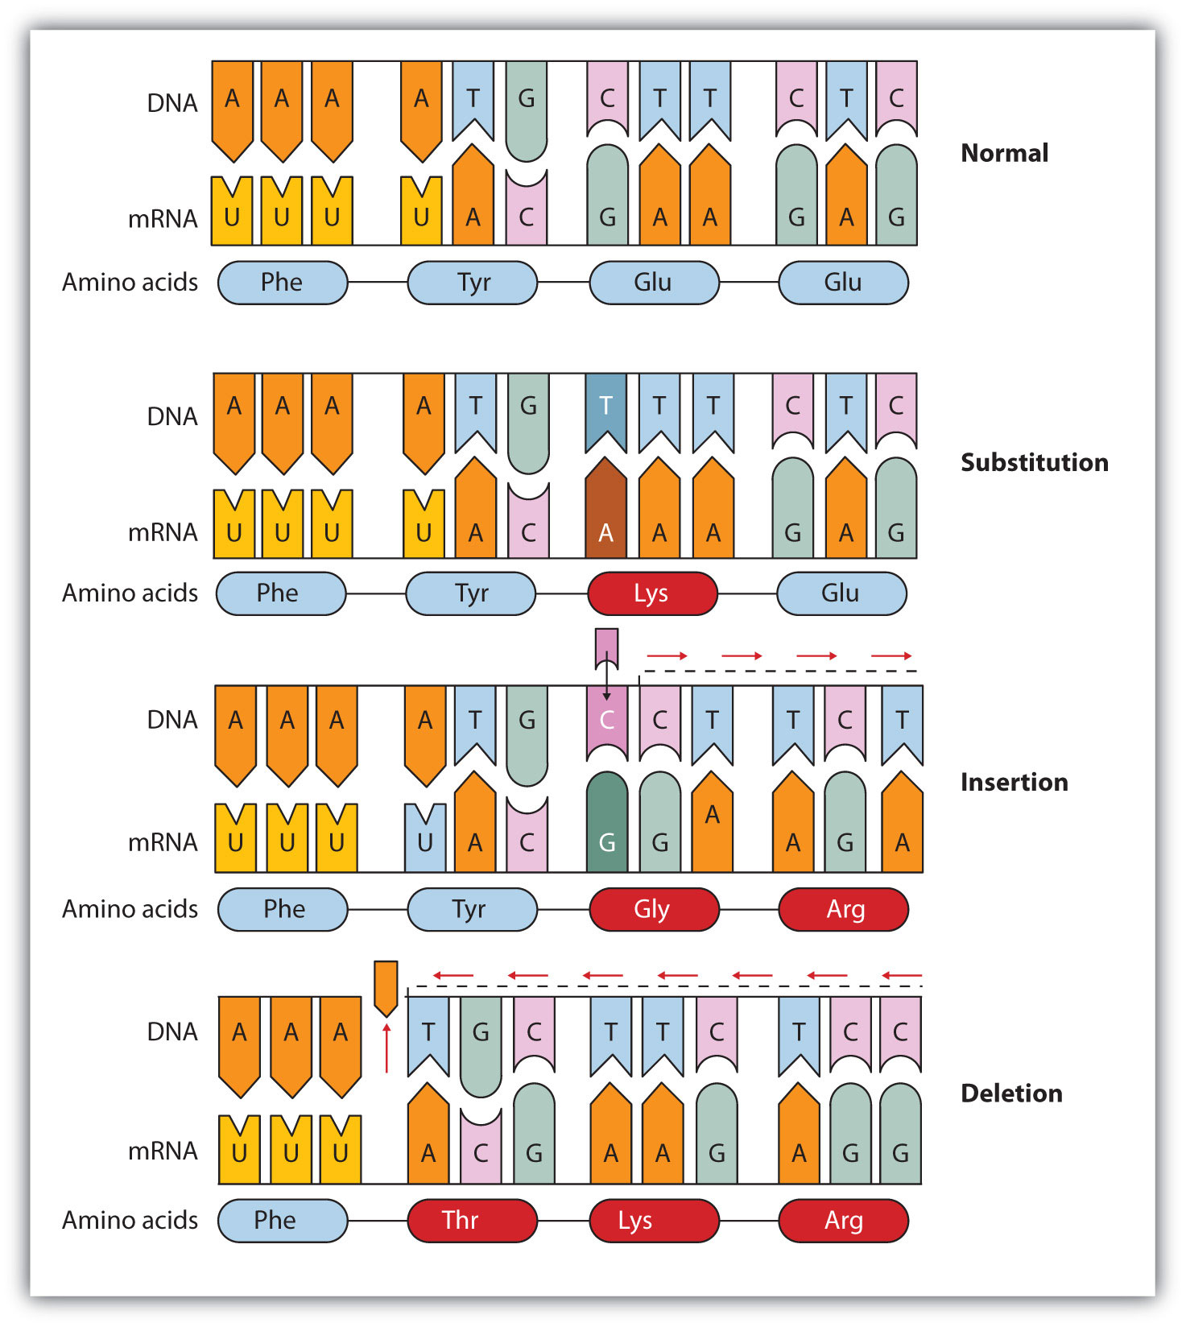
The chemical or physical agents that cause mutations are called mutagens. Examples of physical mutagens are ultraviolet (UV) and gamma radiation. Radiation exerts its mutagenic effect either directly or by creating free radicals that in turn have mutagenic effects. Radiation and free radicals can lead to the formation of bonds between nitrogenous bases in DNA. For example, exposure to UV light can result in the formation of a covalent bond between two adjacent thymines on a DNA strand, producing a thymine dimer (Fig: "An Example of Radiation Damage to DNA"). If not repaired, the dimer prevents the formation of the double helix at the point where it occurs. The genetic disease xeroderma pigmentosum is caused by a lack of the enzyme that cuts out the thymine dimers in damaged DNA. Individuals affected by this condition are abnormally sensitive to light and are more prone to skin cancer than normal individuals.
Fig: An Example of Radiation Damage to DNA
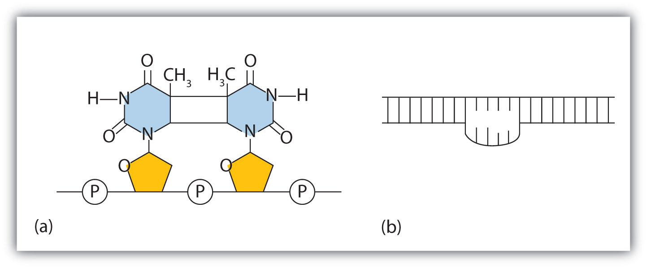
(a) The thymine dimer is formed by the action of UV light. (b) When a defect in the double strand is produced by the thymine dimer, this defect temporarily stops DNA replication, but the dimer can be removed, and the region can be repaired by an enzyme repair system.
Sometimes gene mutations are beneficial, but most of them are detrimental. For example, if a point mutation occurs at a crucial position in a DNA sequence, the affected protein will lack biological activity, perhaps resulting in the death of a cell. In such cases the altered DNA sequence is lost and will not be copied into daughter cells. Nonlethal mutations in an egg or sperm cell may lead to metabolic abnormalities or hereditary diseases. Such diseases are called inborn errors of metabolism or genetic diseases. A partial listing of genetic diseases is presented in Table :"Some Representative Genetic Diseases in Humans and the Protein or Enzyme Responsible", and two specific diseases are discussed in the following sections. In most cases, the defective gene results in a failure to synthesize a particular enzyme.
Table : Some Representative Genetic Diseases in Humans and the Protein or Enzyme Responsible
Disease | Responsible Protein or Enzyme
alkaptonuria | homogentisic acid oxidase
galactosemia | galactose 1-phosphate uridyl transferase, galactokinase, or UDP galactose epimerase
Gaucher disease | glucocerebrosidase
gout and Lesch-Nyhan syndrome | hypoxanthine-guanine phosphoribosyl transferase
hemophilia | antihemophilic factor (factor VIII) or Christmas factor (factor IX)
homocystinuria | cystathionine synthetase
maple syrup urine disease | branched chain α-keto acid dehydrogenase complex
McArdle syndrome | muscle phosphorylase
Niemann-Pick disease | sphingomyelinase
phenylketonuria (PKU) | phenylalanine hydroxylase
sickle cell anemia | hemoglobin
Tay-Sachs disease | hexosaminidase A
tyrosinemia | fumarylacetoacetate hydrolase or tyrosine aminotransferase
von Gierke disease | glucose 6-phosphatase
Wilson disease | Wilson disease protein

PKU results from the absence of the enzyme phenylalanine hydroxylase. Without this enzyme, a person cannot convert phenylalanine to tyrosine, which is the precursor of the neurotransmitters dopamine and norepinephrine as well as the skin pigment melanin.
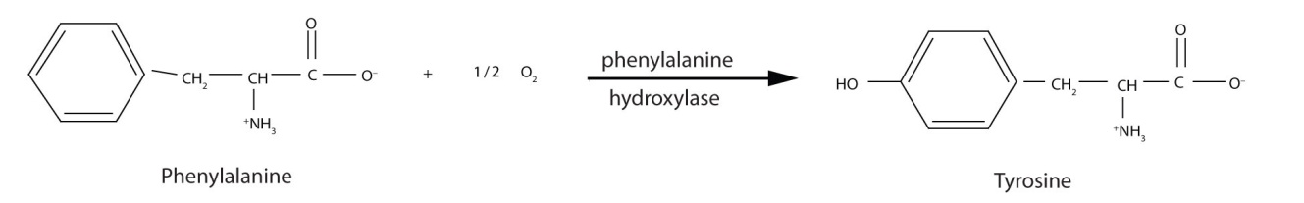
When this reaction cannot occur, phenylalanine accumulates and is then converted to higher than normal quantities of phenylpyruvate. The disease acquired its name from the high levels of phenylpyruvate (a phenyl ketone) in urine. Excessive amounts of phenylpyruvate impair normal brain development, which causes severe mental retardation.
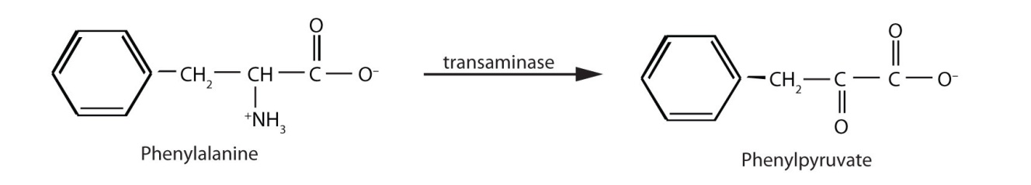
PKU may be diagnosed by assaying a sample of blood or urine for phenylalanine or one of its metabolites. Medical authorities recommend testing every newborn’s blood for phenylalanine within 24 h to 3 weeks after birth. If the condition is detected, mental retardation can be prevented by immediately placing the infant on a diet containing little or no phenylalanine. Because phenylalanine is plentiful in naturally produced proteins, the low-phenylalanine diet depends on a synthetic protein substitute plus very small measured amounts of naturally produced foods. Before dietary treatment was introduced in the early 1960s, severe mental retardation was a common outcome for children with PKU. Prior to the 1960s, 85% of patients with PKU had an intelligence quotient (IQ) less than 40, and 37% had IQ scores below 10. Since the introduction of dietary treatments, however, over 95% of children with PKU have developed normal or near-normal intelligence. The incidence of PKU in newborns is about 1 in 12,000 in North America.
Several genetic diseases are collectively categorized as lipid-storage diseases. Lipids are constantly being synthesized and broken down in the body, so if the enzymes that catalyze lipid degradation are missing, the lipids tend to accumulate and cause a variety of medical problems. When a genetic mutation occurs in the gene for the enzyme hexosaminidase A, for example, gangliosides cannot be degraded but accumulate in brain tissue, causing the ganglion cells of the brain to become greatly enlarged and nonfunctional. This genetic disease, known as Tay-Sachs disease, leads to a regression in development, dementia, paralysis, and blindness, with death usually occurring before the age of three. There is currently no treatment, but Tay-Sachs disease can be diagnosed in a fetus by assaying the amniotic fluid (amniocentesis) for hexosaminidase A. A blood test can identify Tay-Sachs carriers—people who inherit a defective gene from only one rather than both parents—because they produce only half the normal amount of hexosaminidase A, although they do not exhibit symptoms of the disease.

