Md. Nazrul Islam
Department of Chemistry
J.L. N College, Chakradharpur

Recombinant DNA Technology

More than 3,000 human diseases have been shown to have a genetic component, caused or in some way modulated by the person’s genetic composition. Moreover, in the last decade or so, researchers have succeeded in identifying many of the genes and even mutations that are responsible for specific genetic diseases. Now scientists have found ways of identifying and isolating genes that have specific biological functions and placing those genes in another organism, such as a bacterium, which can be easily grown in culture. With these techniques, known as recombinant DNA technology, the ability to cure many serious genetic diseases appears to be within our grasp.
Isolating the specific gene or genes that cause a particular genetic disease is a monumental task. One reason for the difficulty is the enormous amount of a cell’s DNA, only a minute portion of which contains the gene sequence. Thus, the first task is to obtain smaller pieces of DNA that can be more easily handled. Fortunately, researchers are able to use restriction enzymes (also known as restriction endonucleases), discovered in 1970, which are enzymes that cut DNA at specific, known nucleotide sequences, yielding DNA fragments of shorter length. For example, the restriction enzyme EcoRI recognizes the nucleotide sequence shown here and cuts both DNA strands as indicated:
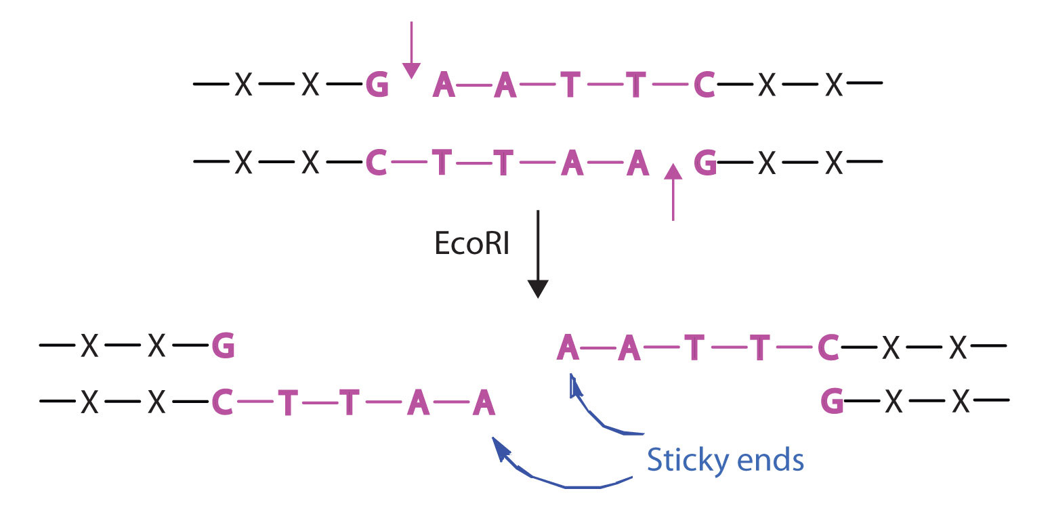
Once a DNA strand has been fragmented, it must be cloned; that is, multiple identical copies of each DNA fragment are produced to make sure there are sufficient amounts of each to detect and manipulate in the laboratory. Cloning is accomplished by inserting the individual DNA fragments into phages (bacterial viruses) that can enter bacterial cells and be replicated. When a bacterial cell infected by the modified phage is placed in an appropriate culture medium, it forms a colony of cells, all containing copies of the original DNA fragment. This technique is used to produce many bacterial colonies, each containing a different DNA fragment. The result is a DNA library, a collection of bacterial colonies that together contain the entire genome of a particular organism.
The next task is to screen the DNA library to determine which bacterial colony (or colonies) has incorporated the DNA fragment containing the desired gene. A short piece of DNA, known as a hybridization probe, which has a nucleotide sequence complementary to a known sequence in the gene, is synthesized, and a radioactive phosphate group is added to it as a “tag.” You might be wondering how researchers are able to prepare such a probe if the gene has not yet been isolated. One way is to use a segment of the desired gene isolated from another organism. An alternative method depends on knowing all or part of the amino acid sequence of the protein produced by the gene of interest: the amino acid sequence is used to produce an approximate genetic code for the gene, and this nucleotide sequence is then produced synthetically. (The amino acid sequence used is carefully chosen to include, if possible, many amino acids such as methionine and tryptophan, which have only a single codon each.)
After a probe identifies a colony containing the desired gene, the DNA fragment is clipped out, again using restriction enzymes, and spliced into another replicating entity, usually a plasmid. Plasmids are tiny mini-chromosomes found in many bacteria, such as Escherichia coli (E. coli). A recombined plasmid would then be inserted into the host organism (usually the bacterium E. coli), where it would go to work to produce the desired protein.
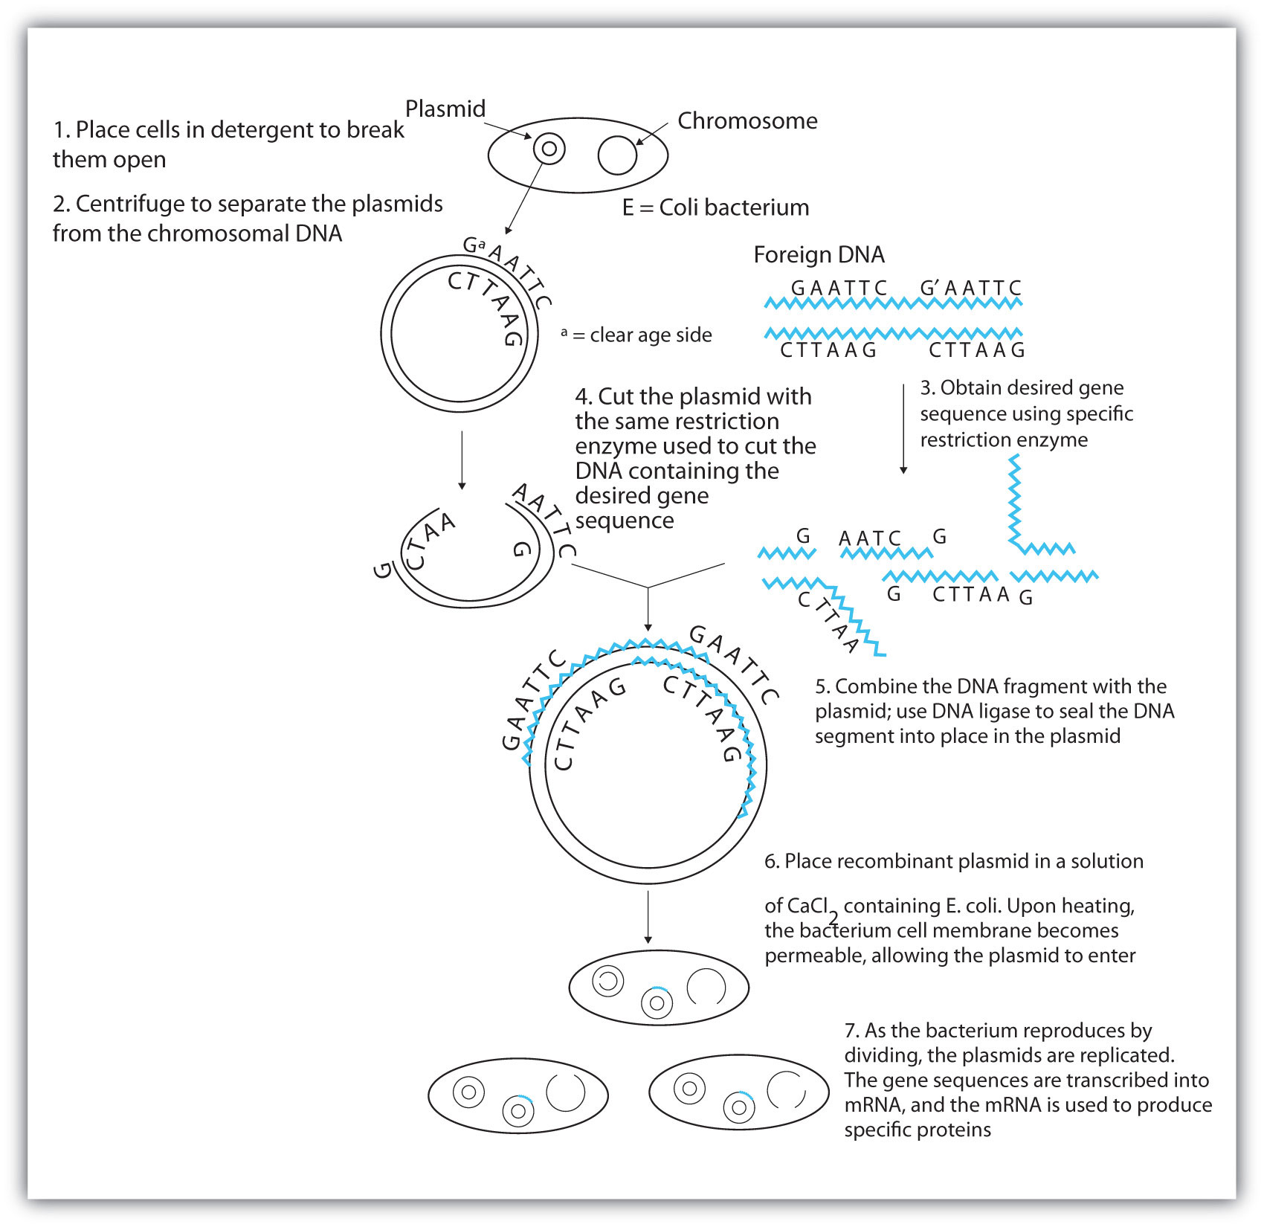
Proponents of recombinant DNA research are excited about its great potential benefits. An example is the production of human growth hormone, which is used to treat children who fail to grow properly. Formerly, human growth hormone was available only in tiny amounts obtained from cadavers. Now it is readily available through recombinant DNA technology. Another gene that has been cloned is the gene for epidermal growth factor, which stimulates the growth of skin cells and can be used to speed the healing of burns and other skin wounds. Recombinant techniques are also a powerful research tool, providing enormous aid to scientists as they map and sequence genes and determine the functions of different segments of an organism’s DNA.
In addition to advancements in the ongoing treatment of genetic diseases, recombinant DNA technology may actually lead to cures. When appropriate genes are successfully inserted into E. coli, the bacteria can become miniature pharmaceutical factories, producing great quantities of insulin for people with diabetes, clotting factor for people with hemophilia, missing enzymes, hormones, vitamins, antibodies, vaccines, and so on. Recent accomplishments include the production in E. coli of recombinant DNA molecules containing synthetic genes for tissue plasminogen activator, a clot-dissolving enzyme that can rescue heart attack victims, as well as the production of vaccines against hepatitis B (humans) and hoof-and-mouth disease (cattle).
Scientists have used other bacteria besides E. coli in gene-splicing experiments and also yeast and fungi. Plant molecular biologists use a bacterial plasmid to introduce genes for several foreign proteins (including animal proteins) into plants. The bacterium is Agrobacterium tumefaciens, which can cause tumors in many plants but which can be treated so that its tumor-causing ability is eliminated. One practical application of its plasmids would be to enhance a plant’s nutritional value by transferring into it the gene necessary for the synthesis of an amino acid in which the plant is normally deficient (for example, transferring the gene for methionine synthesis into pinto beans, which normally do not synthesize high levels of methionine).

